**Project Title:** Translate App

**Team Members:**

Mohammad Itani

**Course:**

System Department Intern

**Instructor:** Mouhanad

September 8, 2025

Contents

Introduction 2

JavaScript Enhancements 6

BackEnd: 8

Nginx Configuration: 10

Container Used: 10

Database 11

Future Enhancements 11

Conclusion 11

# Introduction

This report outlines the work completed during my internship at the System Department, where I focused on developing a web application using modern technologies. The project aimed to address specific operational challenges within the department by providing a streamlined solution for managing user requests and improving overall efficiency. By leveraging tools such as Docker and Nginx, the application was designed to be scalable, maintainable, and user-friendly. This report details the development process, the challenges encountered, and the solutions implemented throughout the project.

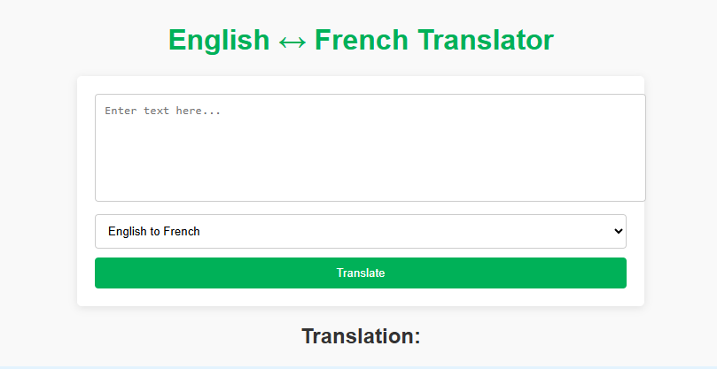

Figure 1: Home Page

Objectives

1. **Develop a Web Application**: Create a user-friendly web application that efficiently manages user requests and enhances operational workflows.
2. **Utilize Docker for Containerization**: Implement Docker to containerize the application, ensuring consistent development and deployment environments across different platforms.
3. **Configure Nginx as a Web Server**: Set up Nginx to serve the application, providing a robust and efficient web server solution.
4. **Implement Core Features**: Develop essential functionalities that meet the specific needs of the System Department, including user authentication, data processing, and request tracking.
5. **Conduct Thorough Testing**: Perform extensive testing of the application to identify and resolve any issues, ensuring a smooth user experience prior to deployment.
6. **Document the Development Process**: Maintain comprehensive documentation of the development stages, configurations, and any challenges faced, to facilitate future work and improvements.

Features

* **Text Translation**:

Support for translating text between multiple languages in real-time.

* **Language Selection**:

A user-friendly interface that allows users to select source and target languages easily.

* **Input Methods**:

Options for users to input text via typing, copy-pasting, or voice input (if applicable).

* **Translation History**:

A feature that saves previous translations for easy access and reference.

* **User Interface**:

A clean, intuitive design that enhances the user experience, making it easy to navigate the app.

* **API Integration**:

Use of translation APIs (like Google Translate API or Microsoft Translator API) to provide accurate translations.

* **Real-Time Translation**:

Instant translation results as users type or input text.

* **Text-to-Speech**:

An option to listen to the translated text being pronounced, enhancing learning and pronunciation.

* **Favorites**:

Users can save commonly used translations or phrases for quick access.

* **Feedback Mechanism**:

Allow users to provide feedback on translation accuracy to improve the service.

* **Responsive Design**:

Ensure the application is mobile-friendly and works seamlessly on different devices.

* **Offline Mode** (if applicable):

Basic translation capabilities without an internet connection, using pre-downloaded language packs.

Technologies Used:

1. Oracle virtual machine
2. linux
3. Frontend: HTML, python
4. Database: MySQL
5. Version Control: Git

# JavaScript Enhancements

Frontend

We used html5 and css for our frontend:

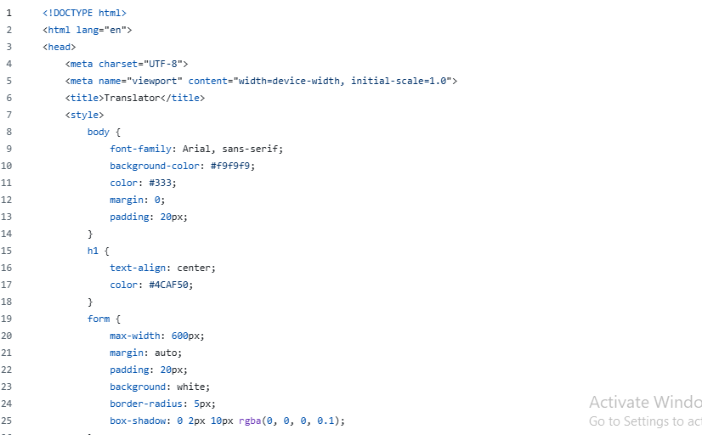

Figure 2: index.html1

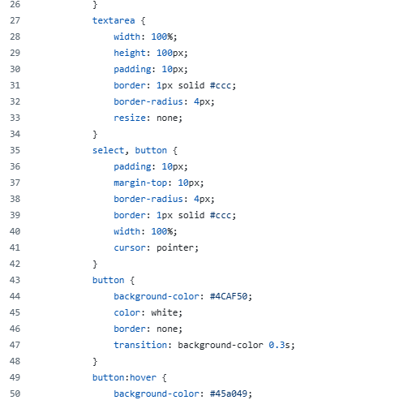

Figure 3: index.html2

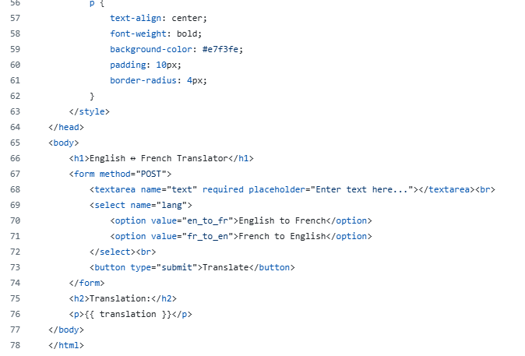

Figure 4: index.html3

# BackEnd:

Used python3 as the backend framework to handle API requests, manage translations, and serve the frontend application.

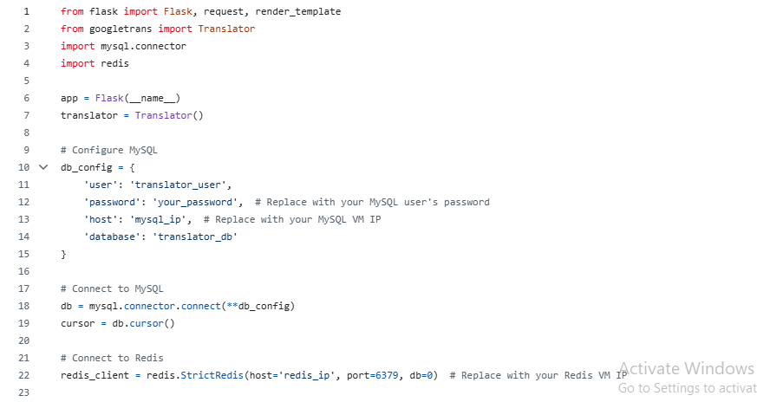

Figure 5: app.py1

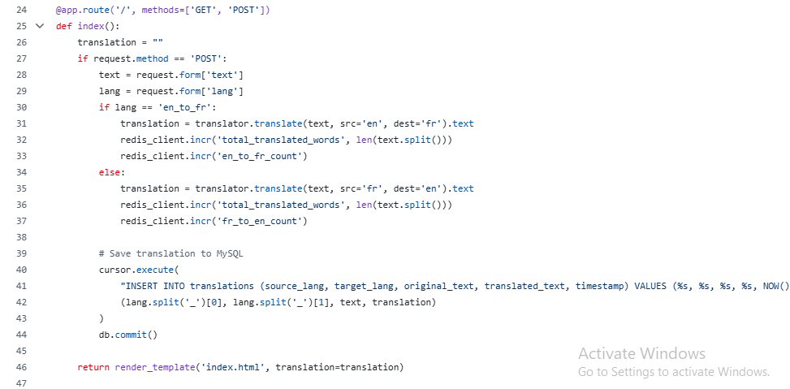

Figure 6: app.py2

# Nginx Configuration:

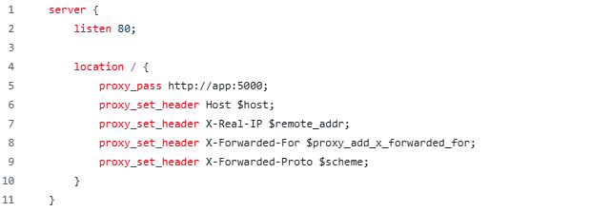

Figure 7: nginx.conf

# Container Used:

We used Dockers as our container since Using a Dockerfile and docker-compose.yml in your translation application helps streamline development, ensure consistency across environments, simplify deployment, and manage dependencies effectively.

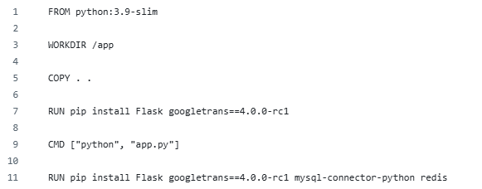

Figure 7: DockerFile

# Database

Our website's database, powered by MySQL, is the storage hub where all data is securely kept. It's structured into tables that hold all the details of our books and users. When a user interacts with our site, MySQL comes into play, saving new information or retrieving what's needed to provide a seamless browsing and shopping experience.

# Future Enhancements

* User Reviews: Allow users to leave reviews for the website.
* AI chatbox: Implement AI to let the user chat to remind the synonym of any word.
* Advanced Search Filters: Add more advanced filters (all languages).

# Conclusion

In conclusion, the development of the translation application has successfully leveraged modern technologies to create a user-friendly and efficient tool for real-time language translation. By integrating a robust frontend framework with a Python-based backend, we have ensured a seamless user experience while maintaining high performance and scalability.

The use of Docker for containerization has streamlined our development and deployment processes, providing consistency across different environments and simplifying the management of dependencies. The incorporation of APIs for translation and text-to-speech functionalities has enriched the application, enabling users to communicate effectively in multiple languages.